**SMARTA Market Research**

Data obtained through publicly available information of a hundred colleges across New York state

1. Student population in upstate New York cities:

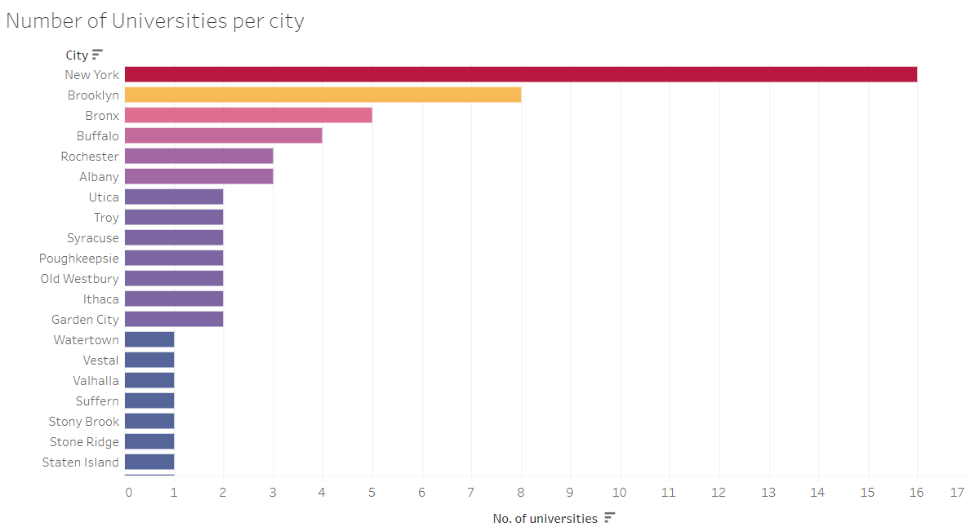

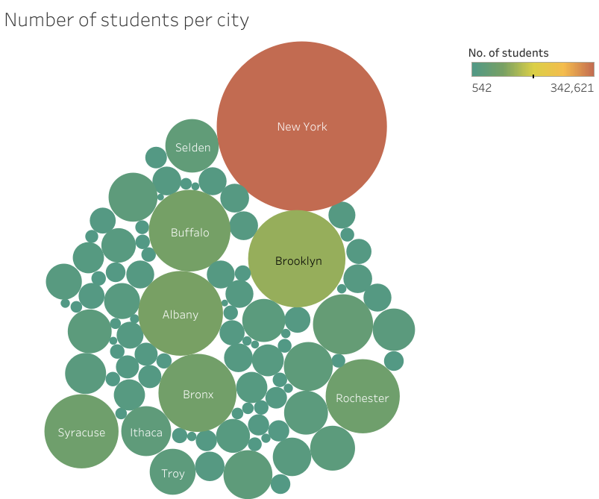

1. Smarta-proposed features:

* Chat Feature

4 universities offer this feature

* Roommate Finder

7 universities have these features listed on their own websites

3 Universities link to external resources for looking for roommates

* House Listings

17 universities provide links to housings on their own websites

36 universities link to external websites for off-campus housing options

* Landlord Contact Info

Universities that have housings listed on their websites provide landlord contact information as well.

* Facilities

Universities with housing information also tend to list housing facilities as well as proximity to nearby places.

1. Interesting extra features offered by other off campus housing websites:

* Explained legal terms, rental process, storage, moving, short term apartments and hotels
* Platform for buying/selling furniture
* Roommate contracts, info about fires, Lease info, community awareness, Renter's insurance
* Review landlords
* Map feature, Favorites
* Legal clinic
* Guide to student housing, rent agreements, being a good neighbor
* Tenant's rights, Transportation services
* Compare utilities prices in the area, Public transportation routes
* Housing conditions checklist, off campus safety, off campus crimes
* Electricity companies guide, Local map, transportation guides
* Tips to find houses, find roommates, control partying and being a good neighbor
* Utilities, tenant rights, lease information
* International students homestay program
* Step by step moving out info, helpful emergency services phone numbers, off campus sustainability guide (eg Recycling, sustainability,farmer's markets), parking info, transportation services
* Housing tips, Off campus housing video guide, information sessions
* Themed rooms for on campus housing(eg for Pet owners, gamers, sports enthusiasts)